Work Log Week 10 and 11
See Jeremy-refactor and Jeremy-modern for changes.
Writing this document – 2 hours
Refactoring – 6 Hours
Five methods that I needed to rename as it didn’t follow camelCase naming so they were renamed.
Before | After
getinventoryItemName() | getInventoryItemName()
setinventoryItemName() | setInventoryItemName()
setinventoryCategory() | setInventoryCategory()
setinventoryUnit() | setInventoryUnit()
setinventoryQuantity() | setInventoryQuantity()

Fixed a problem where the name caused a getter to not find the right item name as it was misnamed. The item name column needed a special-case lambda. After the renaming all four columns are set up the same.
// Before
itemNameColumn.setCellValueFactory(cell ->
new SimpleStringProperty(cell.getValue().getinventoryItemName()));

// After
itemNameColumn.setCellValueFactory(
new PropertyValueFactory<>("inventoryItemName"));
categoryColumn.setCellValueFactory(
new PropertyValueFactory<>("inventoryCategory"));
unitColumn.setCellValueFactory(
new PropertyValueFactory<>("inventoryUnit"));
quantityColumn.setCellValueFactory(
new PropertyValueFactory<>("inventoryQuantity"));

LoginController and RegisterControlled previously contained SQL, database connections and password hashing code mixed in with UI logic. This was extracted into a new interface and implementations following the same structure used for inventory IInventoryDAO and SqliteInventoryDAO.
• IUserDAO: interface declaring addUser, isValidLogin, usernameExists and emailExists.
• SqliteUserDAO: SQLite implementation of IUserDAO holding all SQL for the user’s table.
Code that was moved
Previously in | Now in SqliteUserDAO
RegisterController.createTable() | createTable(), called from the constructor
INSERT statement in RegisterController.onRegisterClick() | addUser(username, email, password)
RegisterController.usernameExists() | usernameExists()
RegisterController.emailExists() | emailExists()
LoginController.isValidLogin() | isValidLogin()
NoSuchAlgorithmException handling in both controllers | One private hash() helper

Changes to the controllers
• Both controllers now hold an IUserDAO field instead of a database Connection, and contain no SQL.
• Each controller has two constructors: a no-argument constructor used by JavaFX, and one that accepts any IUserDAO so a fake DAO can be supplied in tests.
• Validation, messages and navigation logic were left unchanged, so the refactoring does not alter what the user sees.
• Unused JDBC imports (Connection, PreparedStatement, ResultSet, Statement, NoSuchAlgorithmException) were removed.
// Before (LoginController)
private final Connection connection = SqliteConnection.getInstance();
if (isValidLogin(enteredUsername, enteredPassword))
// After (LoginController)
private final IUserDAO userDAO;
public LoginController() { this(new SqliteUserDAO()); }
public LoginController(IUserDAO userDAO) { this.userDAO = userDAO; }
if (userDAO.isValidLogin(enteredUsername, enteredPassword))

This has a side benefit of the user table now being created when either the login or register screen is opened rather than previously only being created by the register screen. When logging in on a new database if it fails it now displays correctly “no such table” in the event a table is missing.
Removed old code from login controller which has unused fields for “logonButton” and “regiserButton”.
Design Patterns and Principles Applied
Pattern / principle | Where it appears
DAO pattern | IUserDAO / SqliteUserDAO now mirror IInventoryDAO/SqliteInventoryDAO, so users and inventory are accessed the same way.
Program to an interface | LoginController and RegisterController depend on IUserDAO and not on SqliteUserDAO or JDBC classes.
Single Responsibility | Controllers handle user input and screen updates. SqliteUserDAO handles storage.
Encapsulation / naming conventions | Inventory accessors follow JavaBean naming, letting JavaFX bind columns by property name.

Enhanced UI – 6 Hours
Login Page Revisions


Register


Inventory
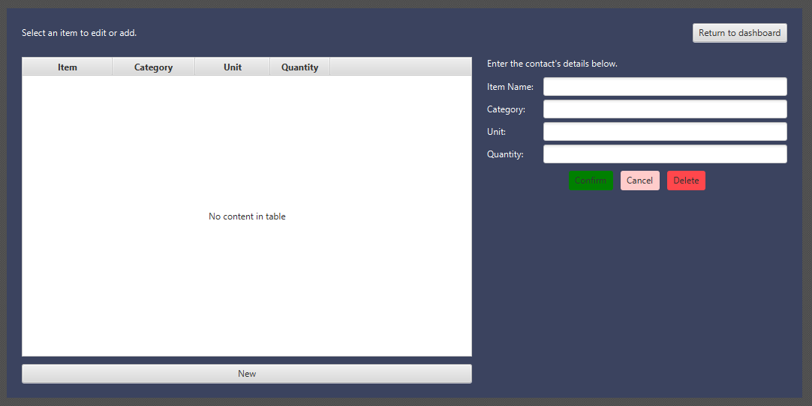
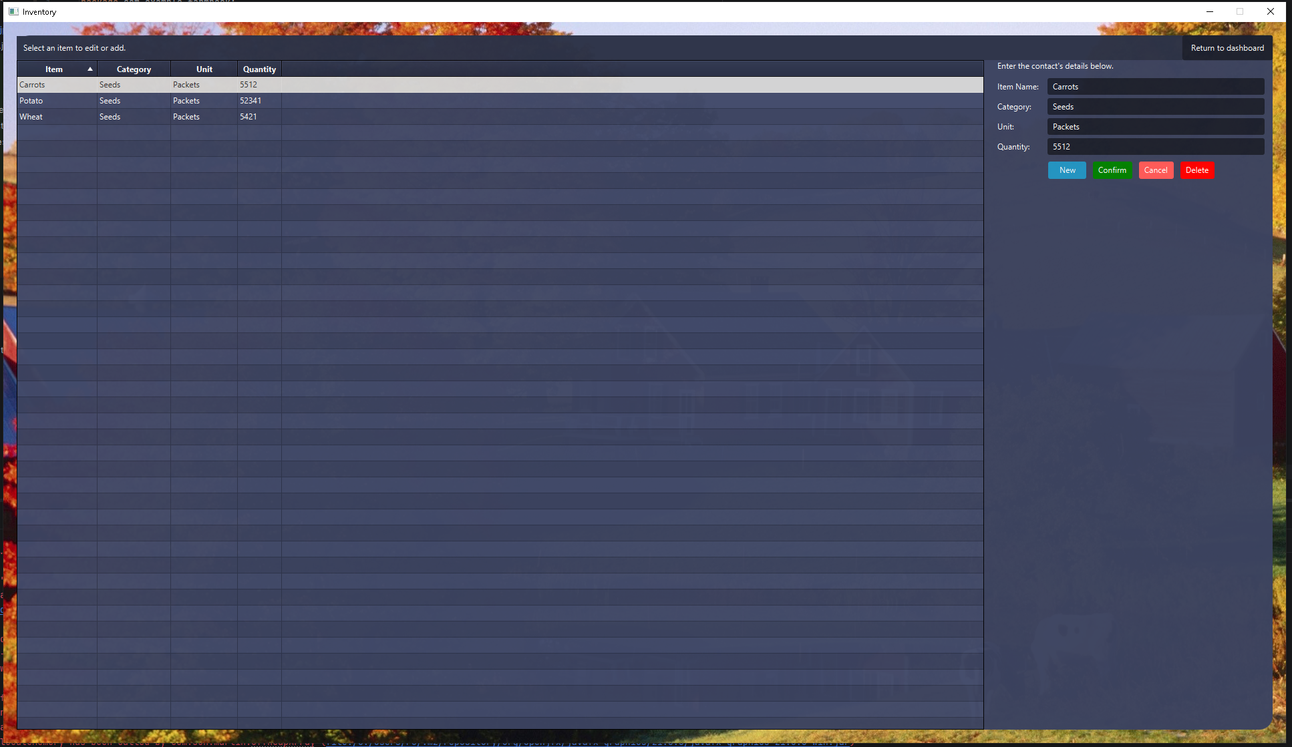
Videos – 1 Hour
https://www.youtube.com/watch?v=EcbgbKtOELY
https://www.youtube.com/watch?v=wIuVvCuiJhU&t=48s
https://www.youtube.com/watch?v=HE4rLEQpiXY&t=181s
https://www.youtube.com/watch?v=GGg61sdEjeI
Resources – 1 Hour
https://www.learnui.design/blog/
https://m3.material.io/get-started

